**IBM Smart Interns Data Analytics Project Documentation**

**TEAM MEMBERS:**

**Brindha S**

**Hari hara Sudhan**

**Vishva Helina J**

**Project Overview**

As part of the IBM Smart Interns data analytics program, a comprehensive project was undertaken to analyze electricity consumption details for the years 2019 and 2020. The project involved leveraging Tableau, a tool covered in the program's training, for data visualization and analysis. The dataset used for analysis was the "State-wise Power Consumption in India" dataset sourced from Kaggle, available at <https://www.kaggle.com/datasets/twinkle0705/state-wise-power-consumption-in-india>.

The primary aim of this project was to analyze and comprehend the electricity consumption patterns over the specified timeframe, with a special emphasis on evaluating any significant changes in consumption trends. Through thorough analysis of the dataset, an intriguing insight emerged: a distinctive alteration in consumption patterns during the period from March to June 2020.

This alteration, which coincided with the nationwide lockdown, suggested a potential link between the lockdown and changes in electricity consumption. The analysis sought to understand the extent and implications of this alteration, shedding light on the broader impact of external factors on energy demand. The exploration of electricity consumption patterns thus became a means to uncover and explore these hidden relationships within the data.

**Project Steps**

**1. Data Collection**

The dataset used for analysis was obtained from Kaggle. It contains state-wise power consumption data for various states in India for the years 2019 and 2020. The dataset includes attributes such as date, region, and power consumption in gigawatt-hours (GWh).

**2. Data Preprocessing**

Before proceeding with the analysis, the dataset underwent several preprocessing steps:

* **Cleaning:** Checked for missing values and outliers in the dataset.
* **Transformation:** Aggregated daily consumption data into monthly values for easier analysis.
* **Merging**: Merged the 2019 and 2020 datasets for comparative analysis.

**Dataset preview**

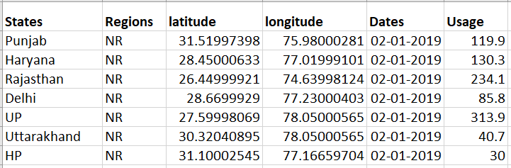

**3. Data Visualization and Analysis in Tableau**

Using Tableau, we have created various visualizations to analyze the electricity consumption patterns:

**Page 1** presents a dynamic bar chart that visualizes electricity usage trends by regions. The chart elegantly showcases the relationship between dates (years), distinct regions, and their corresponding electricity usage.

Tableau link -

<https://public.tableau.com/app/profile/brindha.s3501/viz/Ibmsmartinternsproject-Electricityconsumption-page1/UsagebyRegions?publish=yes>

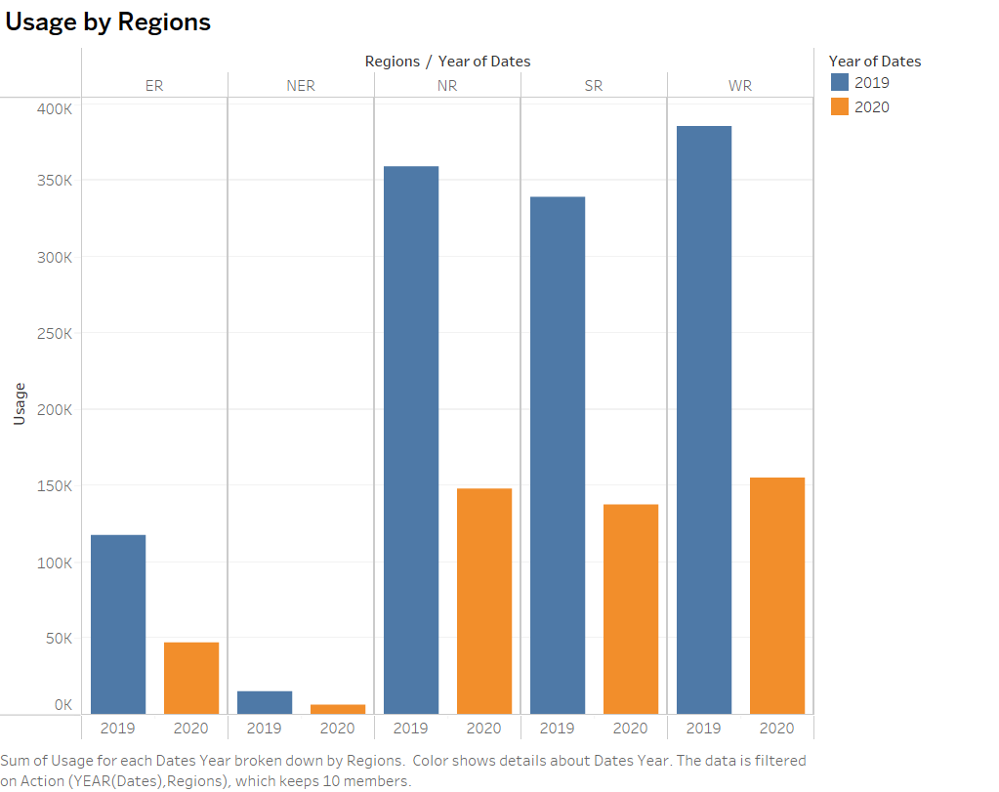

**Page 2** introduces a concise and intuitive pie chart, offering a comprehensive representation of regional electricity usage. The chart distills the complex dataset into a visually digestible format, highlighting the proportional distribution of usage among different regions.

Tableau link –

<https://public.tableau.com/app/profile/brindha.s3501/viz/Ibmsmartinternsproject-Electricityconsumption-page2/Piechartrepresentationofregionalusage?publish=yes>

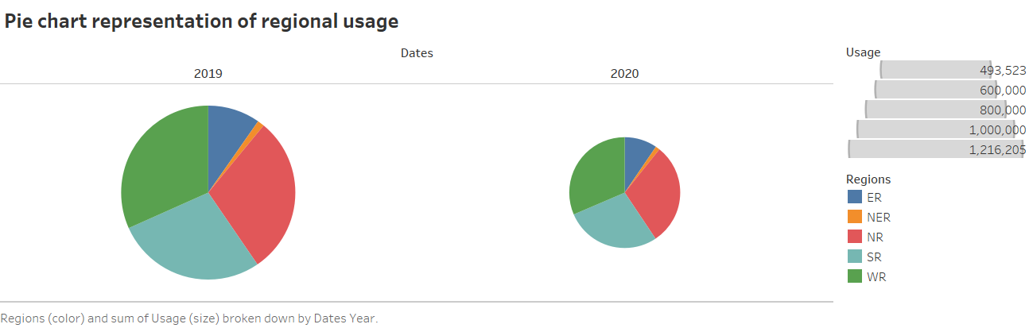

**Page 3** features a comparative line chart that effectively visualizes the differences in electricity consumption between the years 2019 and 2020. The chart highlights the fluctuations in consumption patterns across both years, facilitating a clear understanding of the variations.

Tableau link –

<https://public.tableau.com/app/profile/brindha.s3501/viz/Ibmsmartinternsproject-Electricityconsumption-page3/Differencebetween2019and2020?publish=yes>

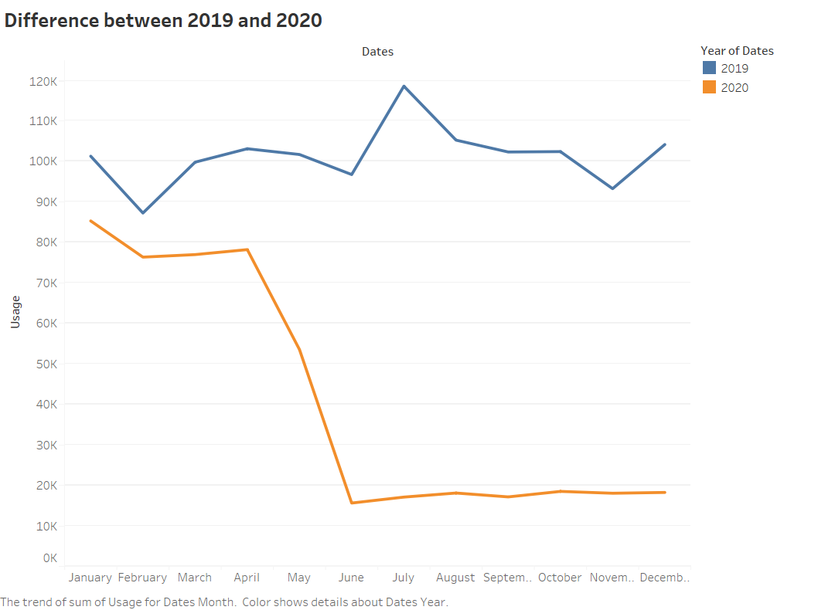

**Page 4** showcases an informative bar chart that portrays the electricity consumption for each state. The chart provides a comprehensive overview of how different states contribute to the overall electricity consumption.

Tableau link –

<https://public.tableau.com/app/profile/brindha.s3501/viz/Ibmsmartinternsproject-Electricityconsumption-page4/Stateconsumptions?publish=yes>

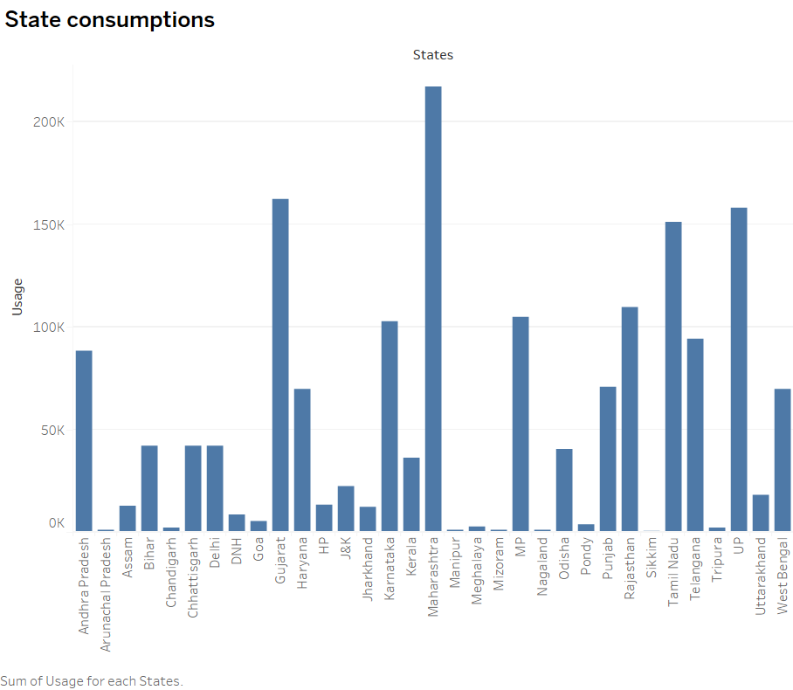

**Page 5** presents an illustrative usage map that effectively communicates the electricity consumption across states in 2019. The variation in color intensity on the India map provides an immediate visual representation of the consumption disparities among different regions

Tableau link –

<https://public.tableau.com/app/profile/brindha.s3501/viz/Ibmsmartinternsproject-Electricityconsumption-page5/UsageMapofStatesin2019?publish=yes>

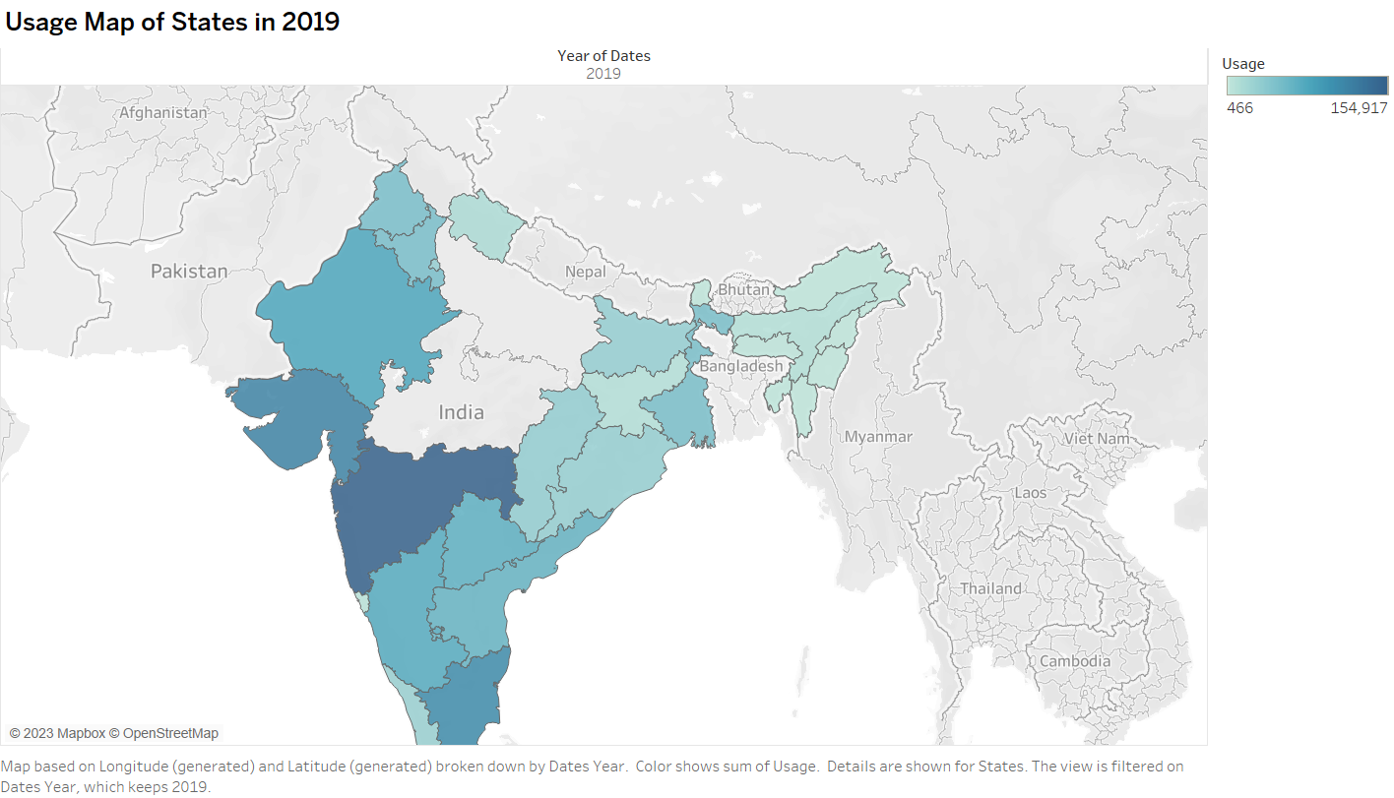

**Page 6** introduces a usage map that visually conveys the electricity consumption patterns across states in the year 2020. The variation in color intensity on the map offers an immediate visual insight into the differing levels of consumption across regions.

Tableau link –

<https://public.tableau.com/app/profile/brindha.s3501/viz/Ibmsmartinternsproject-Electricityconsumption-page6/UsageMapofStatesin2020?publish=yes>

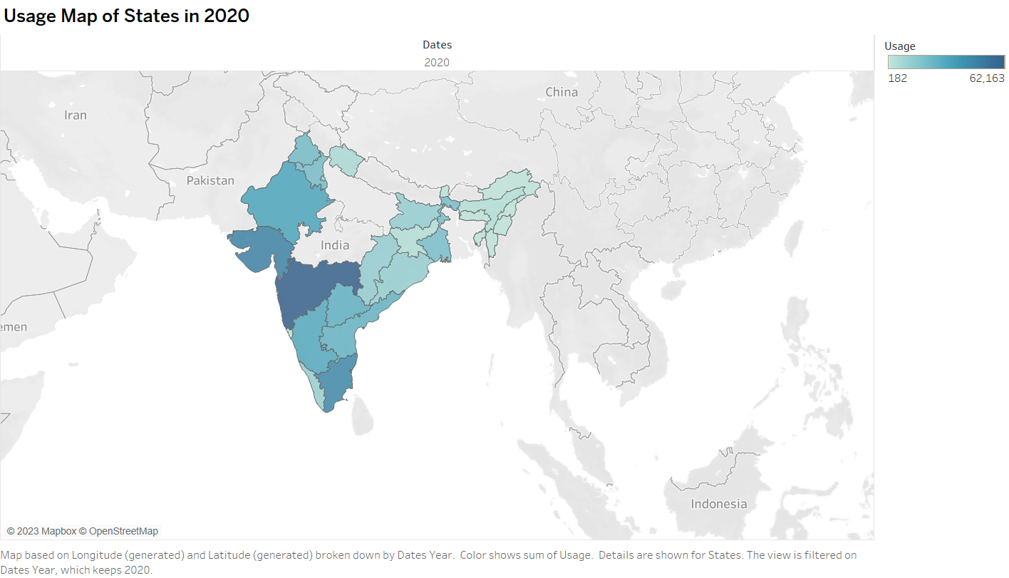

**Page 7** displays a concise bar chart highlighting the top 7 states with the highest electricity consumption in the year 2019. The chart provides a clear snapshot of the states that contributed significantly to the overall consumption.

Tableau link –

<https://public.tableau.com/app/profile/brindha.s3501/viz/Ibmsmartinternsproject-Electricityconsumption-page7/Top7stateconsumptionin2019?publish=yes>

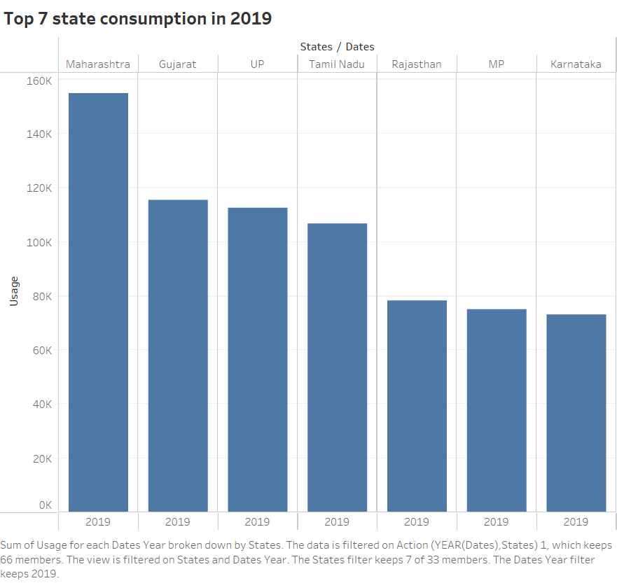

**Page 8** presents a succinct bar graph that highlights the top 7 states with the highest electricity consumption in the year 2020. This graph provides a quick visual comparison of the states that were most influential in shaping consumption patterns during the year.

Tableau link –

<https://public.tableau.com/app/profile/brindha.s3501/viz/Ibmsmartinternsproject-Electricityconsumption-page8/Top7stateconsumptionin2020?publish=yes>

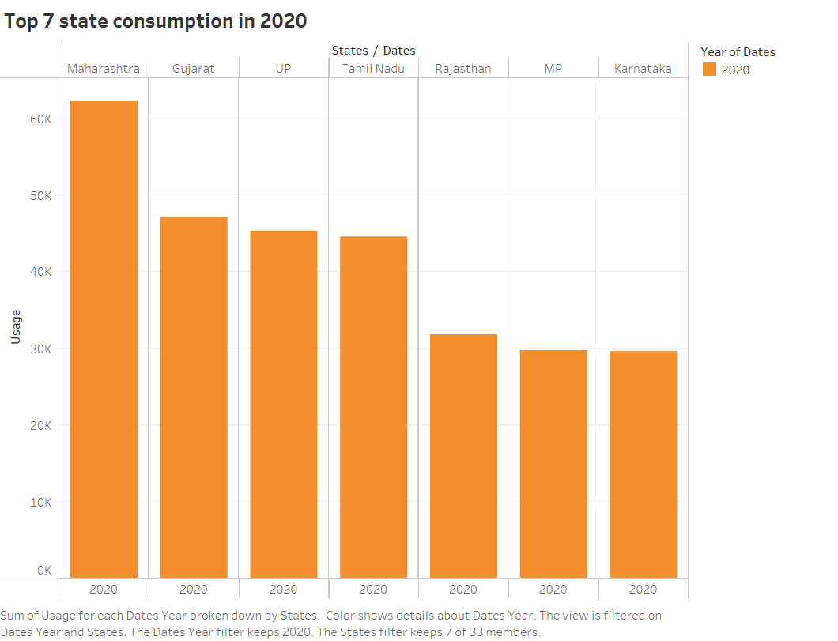

**Page 9** displays a compelling line chart that vividly captures the significant fall in electricity consumption during the year 2020. This chart provides a visual representation of the extent to which consumption declined over the course of the year.

Tableau link –

<https://public.tableau.com/app/profile/brindha.s3501/viz/Ibmsmartinternsproject-Electricityconsumption-page9/Fallin2020?publish=yes>

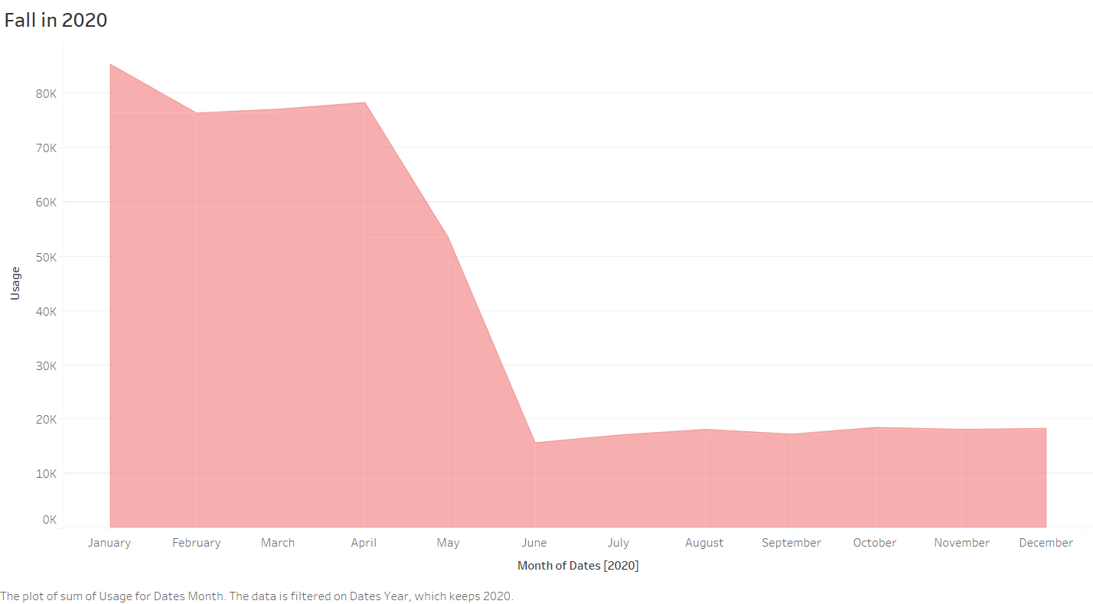

**Page 10** introduces a concise bar chart that effectively illustrates the decline in electricity consumption specifically during the lockdown period. The chart provides a visual overview of how consumption levels dropped during this critical timeframe.

Tableau link –

<https://public.tableau.com/app/profile/brindha.s3501/viz/Ibmsmartinternsproject-Electricityconsumption-page10/Fallduringlockdownperiod?publish=yes>

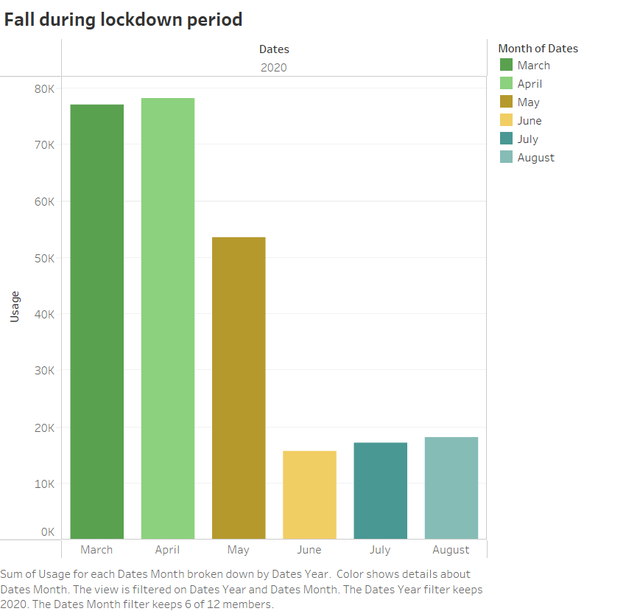

**Page 11** features a visually informative heat map that highlights the reduced electricity usage throughout 2020. This heat map provides a comprehensive visual overview of the specific months and regions where the reduction in consumption was most pronounced.

Tableau link –

<https://public.tableau.com/app/profile/brindha.s3501/viz/Ibmsmartinternsproject-Electricityconsumption-page11/Reducedusagein2020?publish=yes>

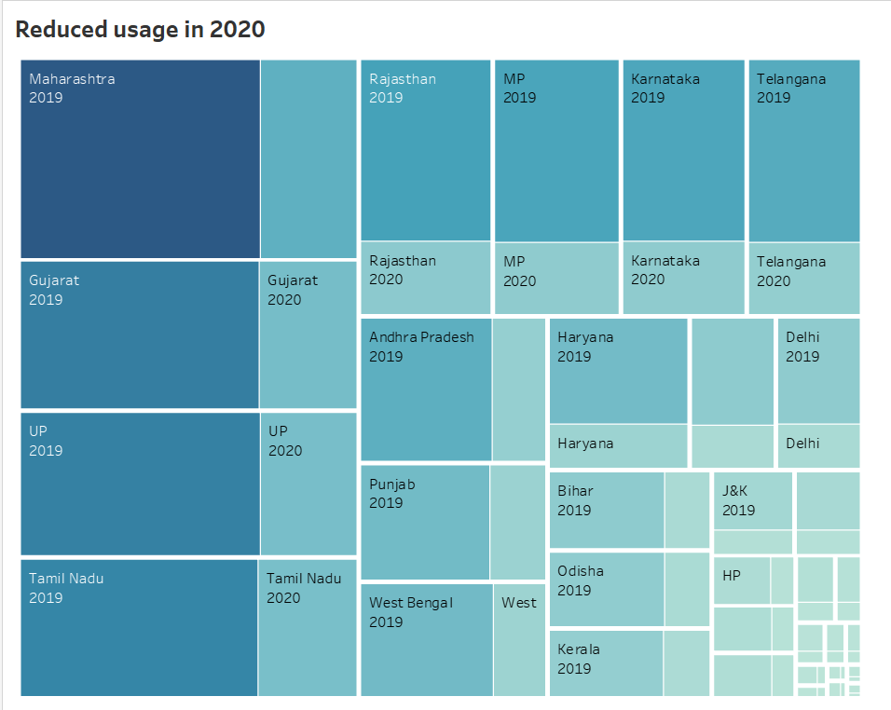

**Page 12** introduces a dynamic packed bubble visualization that showcases the electricity consumption of different states in both 2019 and 2020. This visualization allows for a simultaneous comparison of consumption patterns across the two years.

Tableau link –

<https://public.tableau.com/app/profile/brindha.s3501/viz/Ibmsmartinternsproject-Electricityconsumption-page12/Stateconsumptionboth20192020?publish=yes>

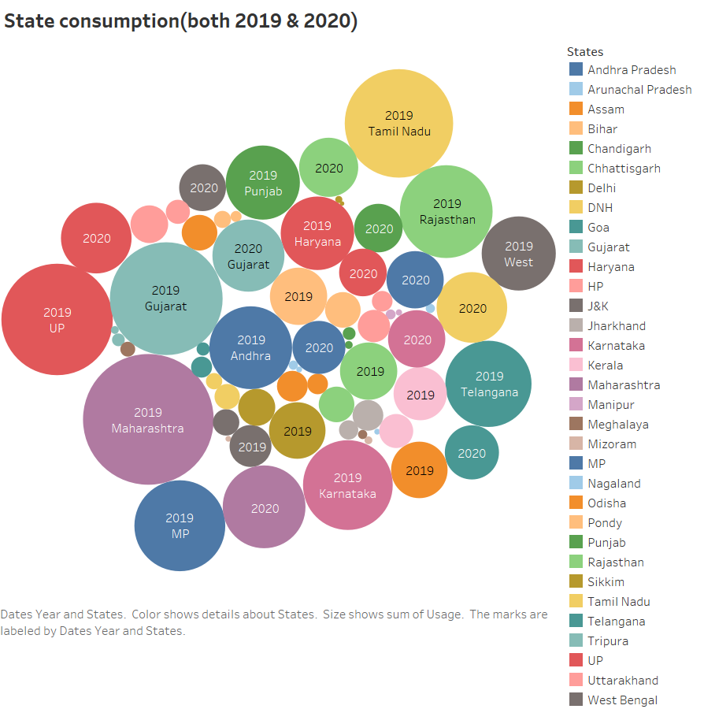

**DASHBOARD -1**

The interactive dashboard on this page combines the insightful visualizations from Pages 5, 6, 7, and 8. It seamlessly integrates the usage maps for 2019 and 2020, the top 7 state consumption bar charts for both years, and offers an interactive feature that enables users to interactively highlight states on the map and observe their corresponding consumption in the bar chart."

Tableau link –

<https://public.tableau.com/app/profile/brindha.s3501/viz/Ibmsmartinternsproject-Electricityconsumption-dash1/Dashboard1?publish=yes>

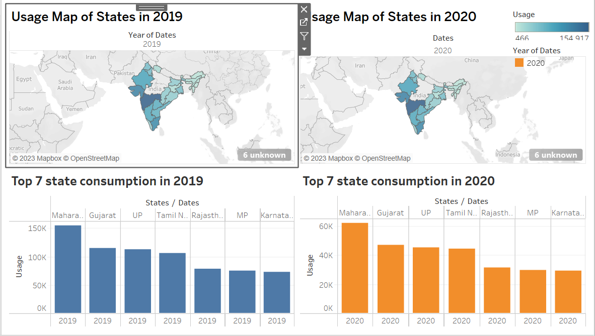

**DASHBOARD - 2**

The second interactive dashboard presented here combines the insightful visualizations from Pages 1 and 2. It seamlessly integrates the bar chart depicting usage by regions and the pie chart illustrating regional consumption distribution. This dashboard also offers an interactive feature that allows users to select a region on the bar chart to highlight it in the pie chart.

Tableau link –

<https://public.tableau.com/app/profile/brindha.s3501/viz/Ibmsmartinternsproject-Electricityconsumption-dash2/Dashboard2?publish=yes>

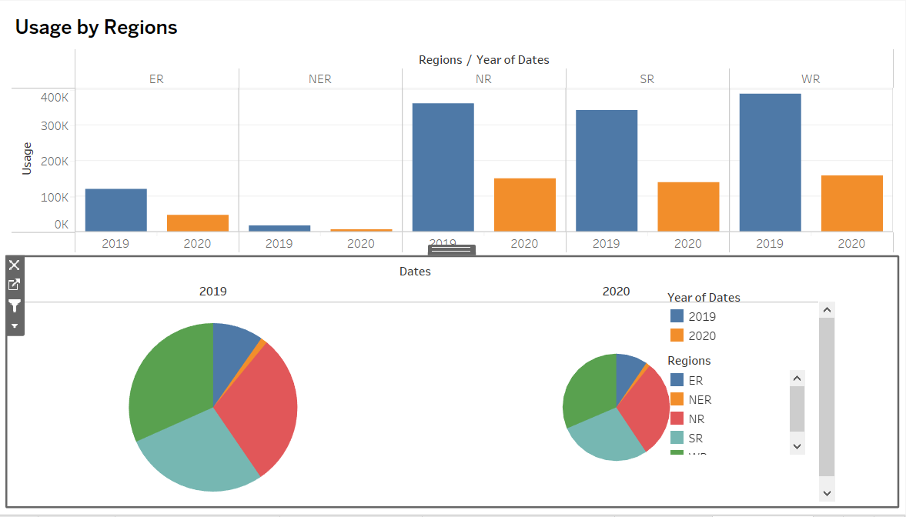

**4. Data Insights**

Through data analysis and visualization, the following insights were gained:

There was a noticeable decline in electricity consumption during the lockdown period (March to June 2020) compared to the same months in 2019.

The decline was observed across most states, indicating a widespread impact of the lockdown on energy consumption.

Certain states experienced sharper drops in consumption compared to others, potentially due to variations in industrial activity.

**5. Storytelling with Tableau**

To communicate the findings effectively, I created a storytelling component in Tableau. The storytelling feature allowed me to weave together different visualizations and insights into a cohesive narrative. The story emphasized the impact of the lockdown on electricity consumption and highlighted the variations between states.

Story-

<https://public.tableau.com/app/profile/brindha.s3501/viz/Ibmsmartinternsproject-Electricityconsumption-story/Story2?publish=yes>

**Conclusion**

**Successful Application of Data Analytics:**

Demonstrated practical data analytics skills using Tableau to analyze electricity consumption trends in India during 2019 and 2020.

**Emphasis on Consumption Patterns:**

Explored intricate electricity consumption patterns over the given period, including variations in timeframes and regions.

**Highlight on Lockdown Period:**

Focused on understanding changes in consumption during the 2020 lockdown, uncovering potential external influences.

**Effective Visualization and Insights:**

Employed diverse visualizations like bar charts, line charts, and maps to generate valuable insights from the dataset.

**Interactive Dashboards Enhance Understanding:**

Integrated interactive dashboards, enabling users to engage with data by selecting regions and states for deeper insights.

**Compelling Storytelling Elements:**

Used storytelling techniques to weave visualizations and insights into a cohesive narrative, enhancing communication.

**Comprehensive Documentation:**

Captured the entire project journey, from data collection to insights presentation, providing a clear roadmap for replication.

**Learning Opportunity:**

Beyond immediate goals, documentation serves as an educational resource, sharing methodologies, visualization effectiveness, and data analysis skills.

In summary, this project exemplifies effective data analytics, visualization, and storytelling to derive insights from complex data, focusing on consumption patterns and external impacts. The documentation serves as a valuable learning tool and offers a structured approach for future projects.